1. **Creating Auto Scaling Group….?**
2. **Steps for creating autoscaling groups…**
3. **Autoscaling group created through ec2 launch templates..**

**A.Create new launch template option available left side at instances group.**

**B.Select and create launch template..**

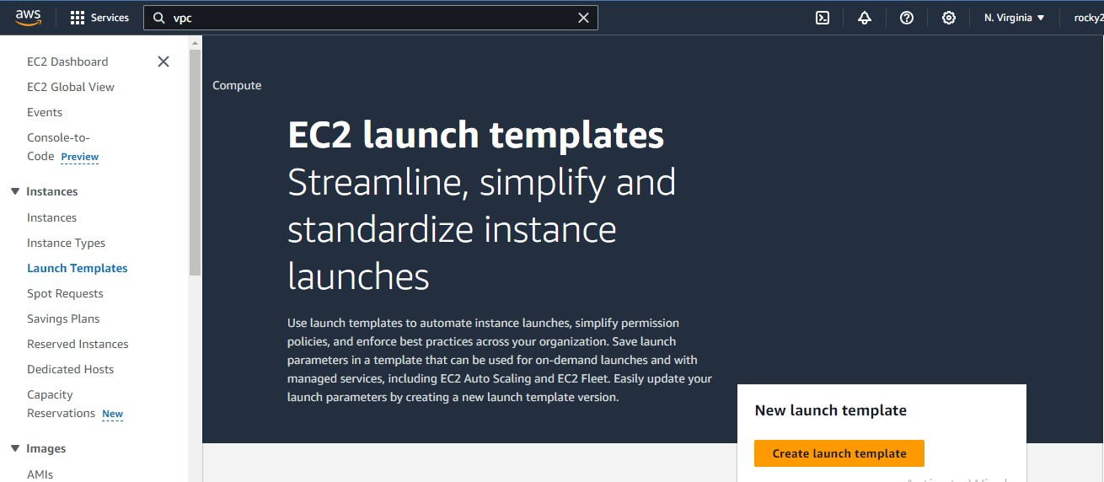

1. **Add template name and description.. as shown in below image..**

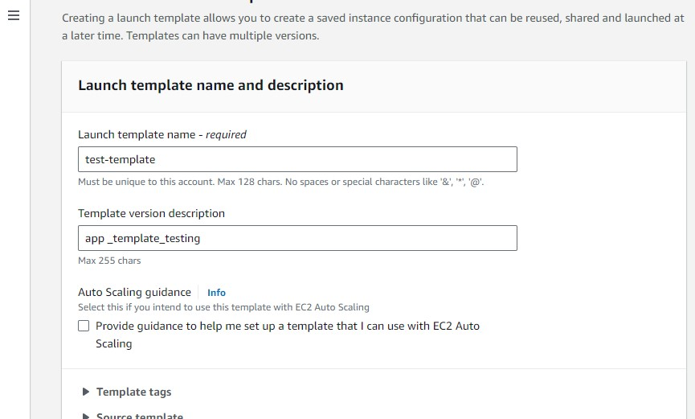

1. **And next select the option quick start instead of my AMIs..**

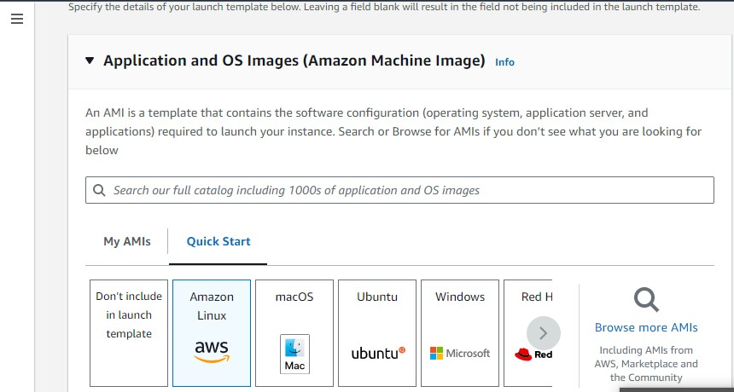

1. **Next don’t create key pair..**
2. **Don’t include subnets..**
3. **Select default VPC..**
4. **Select Volume type General GP2…**
5. **Next create launch template…**
6. **Below Both images shown creating templating…**

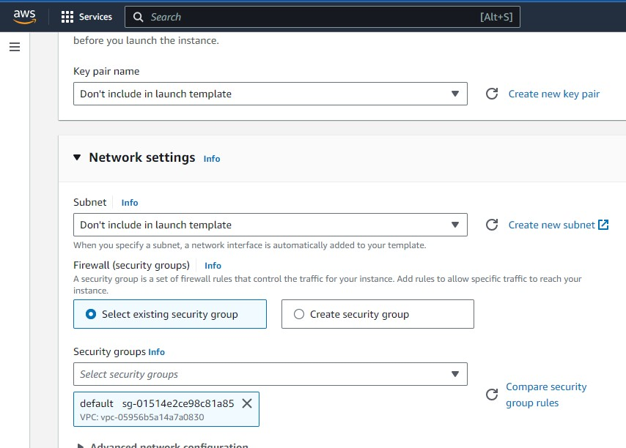

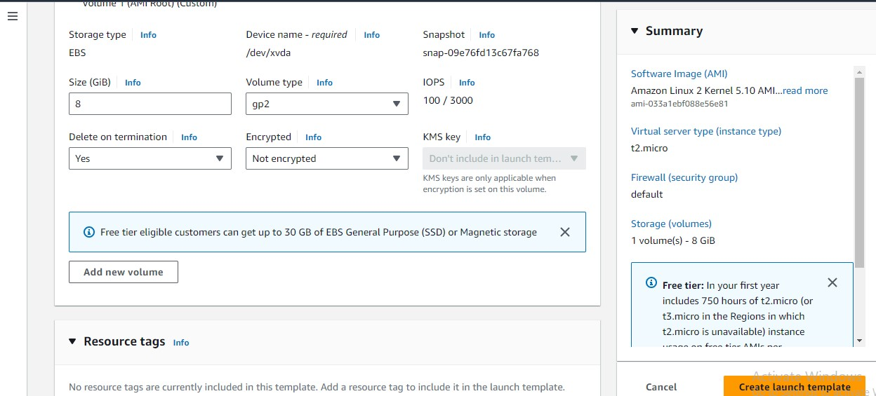

1. **New template Launched…Next go to Auto scaling groups….**

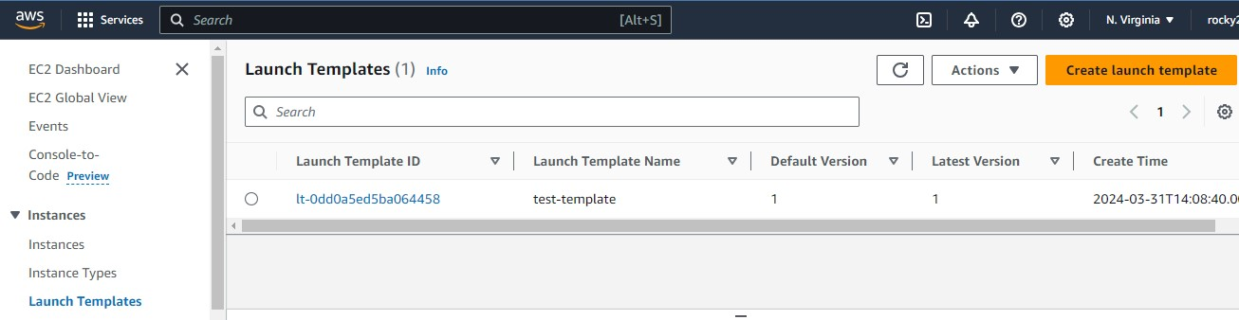

1. **In ASG Create auto scaling group..**
2. **In that ASG Choose launch template..**
3. **Add name**
4. **IN VPC section select default VPC…below images shown the fields with selected option..**

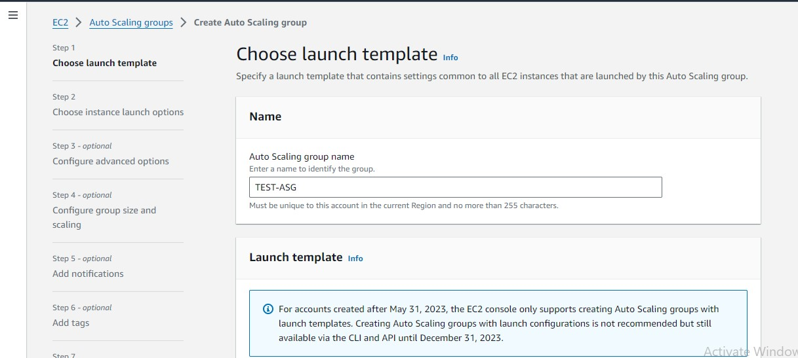

1. **Add default subnet and click on next button…**

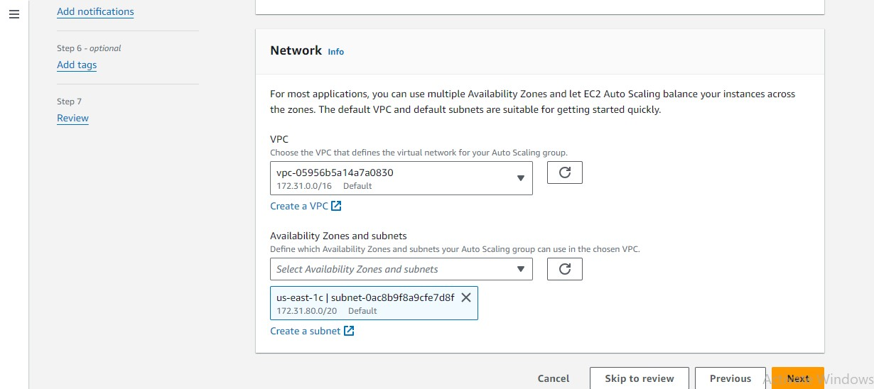

1. **Add desired capacity and scaling limits …**
2. **Desired capacity given :- 3**
3. **Scalling limits…MIndesiredcapacity:- 2 & max desired capacity :- 4**

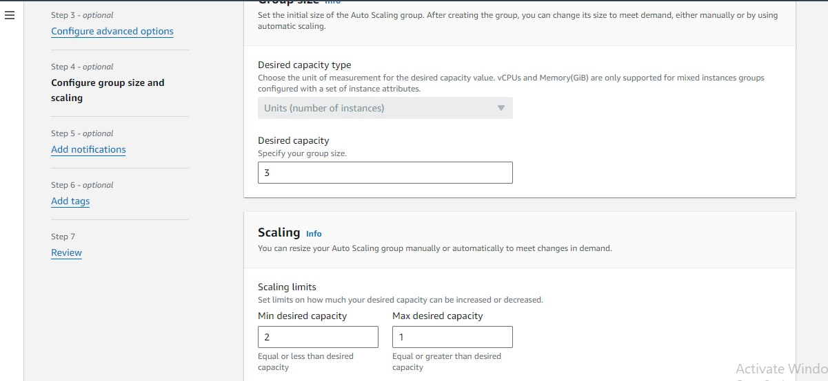

1. **Next option automatic scaling..**
2. **Here selected NO scaling option…**

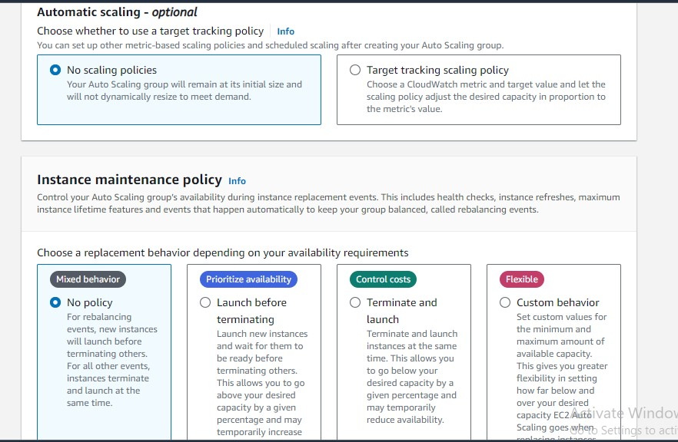

1. **ASG created Tag name as TEST-ASG….**

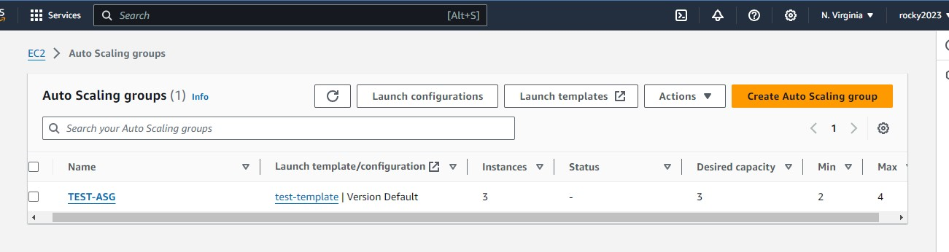

1. **After adding all required credentials…created ASG with Multiple instances…below image shown clearly…**

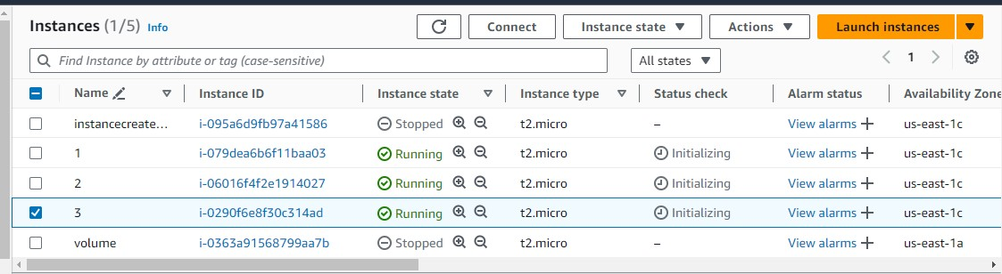

1. **Here select one instance and terminate for to test auto scale…selected and terminated..**

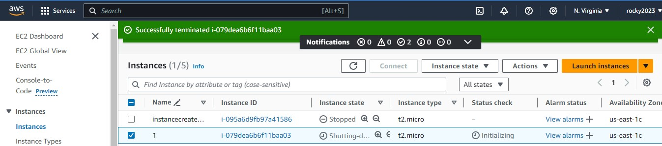

1. **After terminating automatically created new instance as shown in below image….**



